**JIRA PROJECT DOCUMENTATION**

**Name:** Aastha Saxena  
**Project Name:** Aastha_my_practice  
**Tool Used:** Atlassian Jira

**1. Objective**

The aim of this project was to gain hands-on experience with Agile project management using Jira. I created a mock Scrum project to simulate a real-world product development environment, focusing on issue tracking, status updates, and workflow management.

### ****2. Project Overview****

* **Project Name – Aastha_my_practice**
* **Purpose: Practice and experiment with Jira features such as issue tracking, workflows, boards & dashboards.**
* **Platform: Atlassian Jira**
* **Project type: Team managed project**

**3. Dashboard overview:**

**Activity summary last 7 days:**

* **3 Completed**
* **3 Updated**
* **0 Due soon**

**This section provides a high level summary of all the recent activities with the project.**

**4. Status Overview:**

* **Total Work Items Created:** 7
* **Work Items Completed (Last 7 Days):** 3
* **Work Items Updated (Last 7 Days):** 3
* **Work Items in Progress:** 0

This shows effective closure of all listed tasks in the sprint timeline.

The status overview is displayed visually using a donut chart of the Jira dashboard.

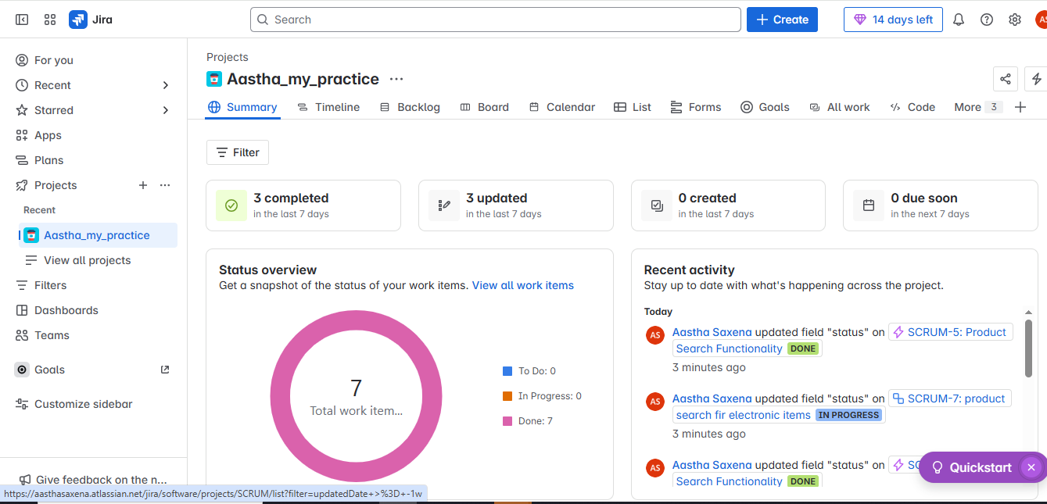

### ****5. Key Activities****

* Created tasks and sub-tasks relevant to a product development cycle.
* Updated issue statuses through various stages: "To Do", "In Progress", and "Done".
* Used tags and field updates for tracking issue progress.
* Maintained clear documentation in issue descriptions for team visibility.

### ****6. Sprint Activities****

* **Sprint Planning:** Defined backlog items and estimated story points.
* **Daily Standups (Simulated):** Monitored progress via activity logs and updated statuses.
* **Sprint Review:** Verified completion of all tasks; all work items transitioned to DONE.
* **Sprint Retrospective:** Reflected on challenges and improvements for the next cycle

### 7. **Recent Activity**

### **The "Recent Activity" panel lists all recent changes to issues, including comments, status updates, and edits.**

### **Aastha Saxena updated the field "status" on the issue Dashboard page development to DONE.**

### **Aastha Saxena commented on the issue PRAC-2: Dashboard page development:**

### **"Development started"**

|  |  |  |  |  |  |  |  |  |  |  |  |  |  |  |  |  |
| --- | --- | --- | --- | --- | --- | --- | --- | --- | --- | --- | --- | --- | --- | --- | --- | --- |
| |  |  | | --- | --- | | **Feature** | **Description** | | **Boards** | **Visualize and manage tasks across workflow columns (e.g., To Do, In Progress, Done).** | | **Timeline** | **Provides a Gantt-style view of tasks and scheduling.** | | **Backlog** | **Contains a list of planned and upcoming work items.** | | **Calendar** | **Schedule tasks and view their due dates visually.** | | **Forms** | **Create structured forms for task submission.** | | **Reports** | **Track progress, completion rates, and issue statistics.** | | **Recent Activity** | **Keeps a live feed of all updates across the project.** | |

### ****8. Recommendations for Further Practice****

### ****Create and manage different issue types:** Story, Task, Bug, Epic.**

### ****Customize workflows:** Add new statuses or transitions.**

### ****Assign issues:** Set assignees, priorities, and deadlines.**

### ****Use automation rules**: Automatically assign or transition issues.**

### ****Explore sprints and backlog planning** for Agile workflows.**

### ****Add components, labels, and custom fields** to organize tasks.**

### ****Enable notifications and permissions** to simulate** team collaboration